SBPS Website Restructuring - My Review
Social Baluni Public School | https://www.sbpsdoon.com/
I checked the current website and noted a few areas that can be improved. My main focus is to make the website cleaner, easier to use and easier for the school team to keep updated.

Security Related Concern
Current site is using WordPress CMS with PHP version 7.4.33, which has reached End-of-Life (EOL) and is no longer receiving security updates. The PHP runtime should be upgraded to a currently supported version to mitigate security risks such as unpatched vulnerabilities, potential remote code execution, and memory/buffer-related vulnerabilities, while ensuring compatibility with the latest WordPress core, themes, and plugins.
Key security concerns include:
- Unpatched vulnerabilities: PHP 7.4 is EOL, meaning newly discovered security vulnerabilities are no longer routinely patched.
- Potential code-execution risks: Vulnerabilities in an unsupported PHP runtime can potentially be exploited to compromise the application or execute malicious code, depending on the affected functionality and configuration.
- Memory/buffer vulnerabilities: PHP 7.4.33 itself was already released as a security release fixing issues including an out-of-bounds read and a buffer overflow, illustrating the importance of staying on a supported PHP branch.

Main problems I found on the current site
- Old content: some old notices and 2019-21 exam/admission items are still visible.
- Placeholder text: messages such as “Empty tab. Edit page to add content here” and “This is custom heading element” are visible to visitors.
- Sports: the sports section is mainly shown as a list, and “Athletics” appears twice.
- Image quality: some images look a little light and can be improved to make the website more attractive.
- Enquiry form: the current form looks old and can be made simpler and easier to use.
- News and Events: the information is mostly shown as text/list items, so it is harder to scan quickly.

News and Events
I would change this section from a mainly text-based list to simple cards. Each card can have an image, title, short description and a “Read More” or “View Details” link. This would make important updates easier to notice and share.

Current view
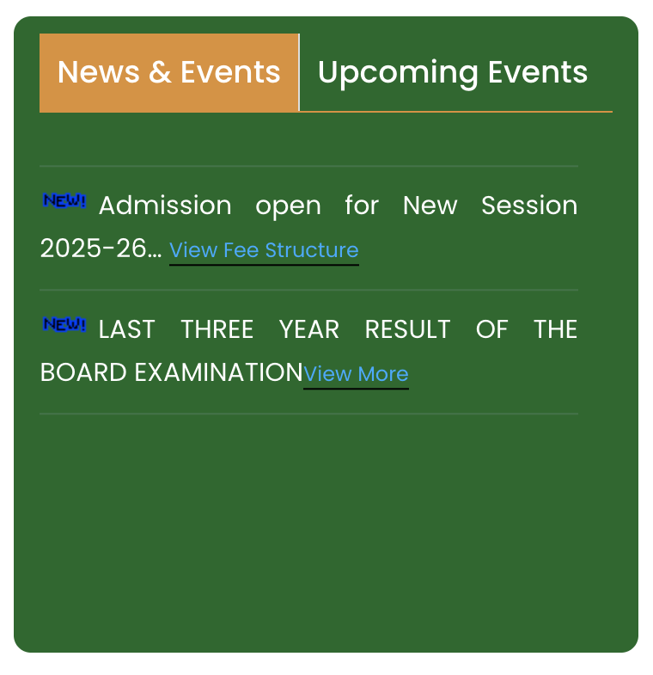

Suggested style
As a reference, I looked at Mindstretcher (https://www.mindstretcher.com/). I like the way they show current updates as separate cards with images and short text. A similar idea can be used for SBPS, with school-specific content.
Reference example
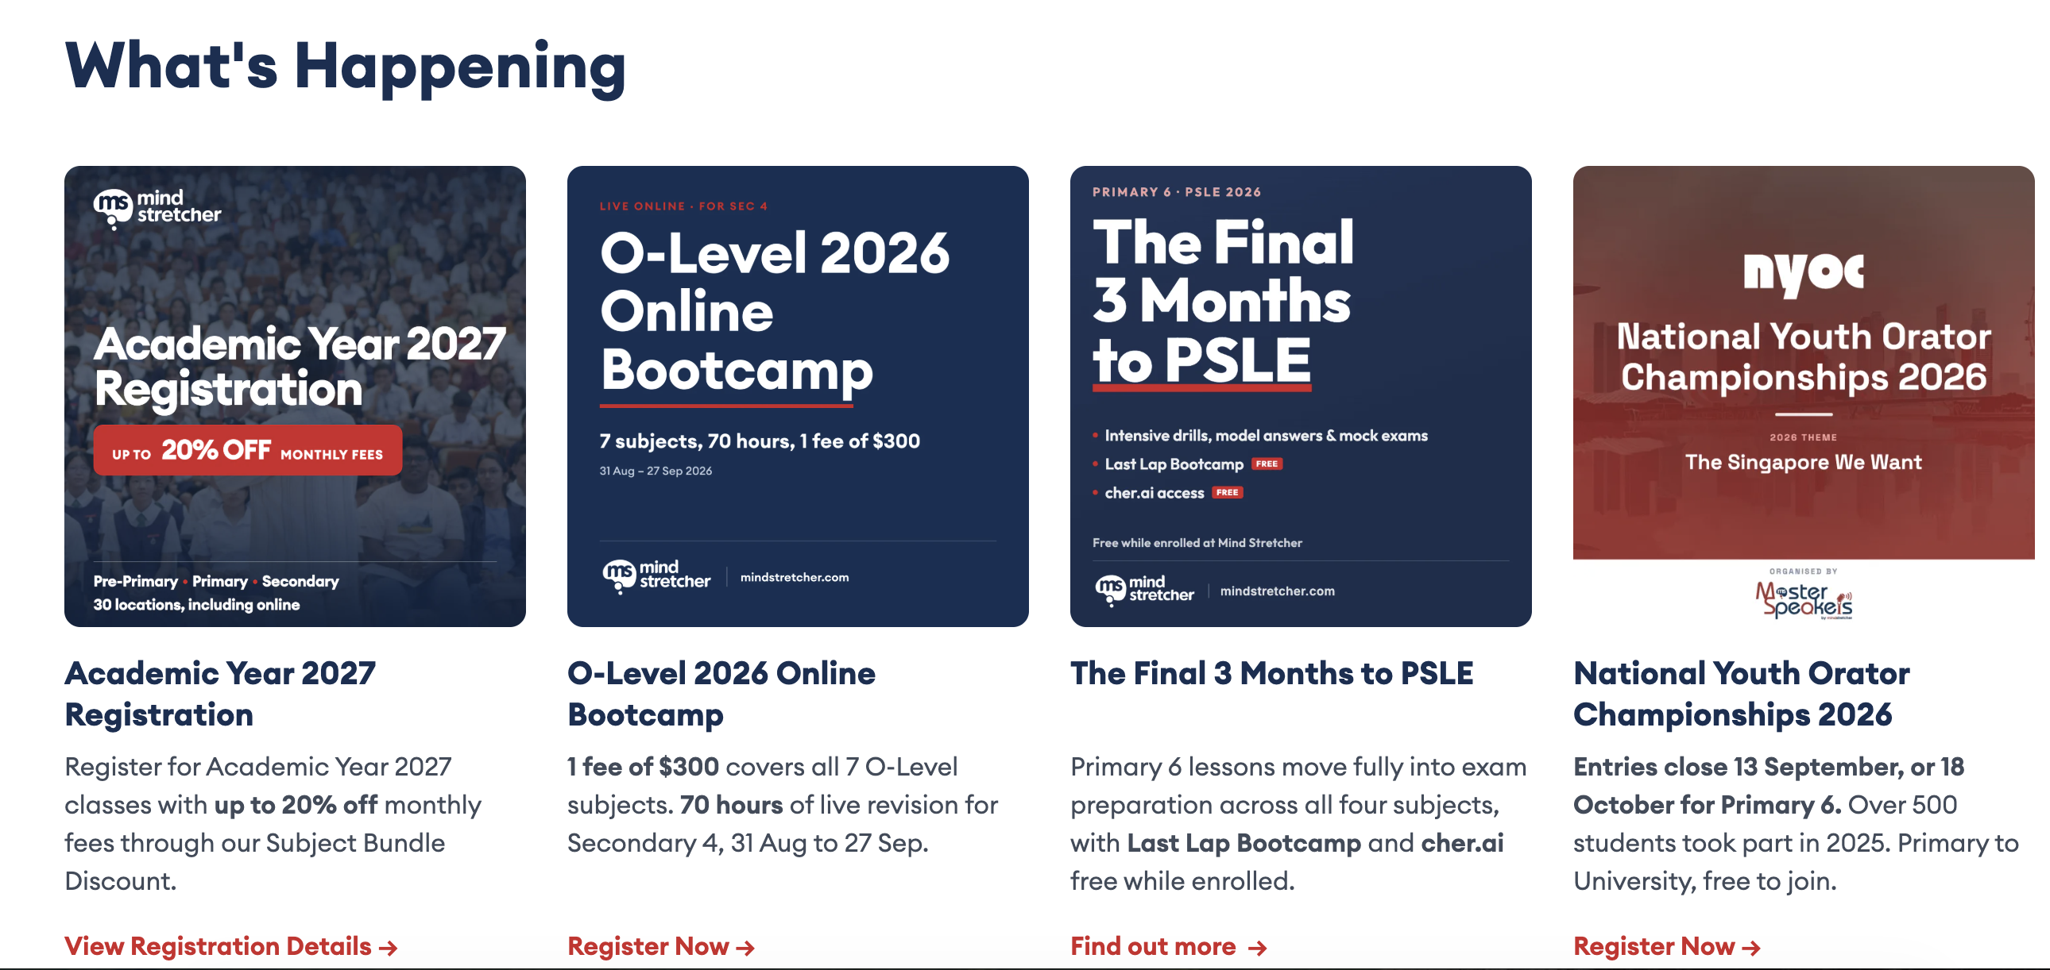

CMS options to consider
- Strapi - https://strapi.io
- Directus - https://directus.com
- Drupal - https://new.drupal.org

My suggestion
I would use a CMS so the school team can update News, Events, Notices, Admissions, Academic Programs, IIT/NDA preparation, Sports, Achievements, Faculty and Gallery without changing code each time.
The main aim is to make the website look better, but also to keep the information current and make it easier for parents, students and visitors to find what they need.

Next steps
- Create a cleaner homepage with clear sections and better images.
- Use cards for News, Events, Sports and Achievements instead of long lists.
- Improve the enquiry/admission form, especially for mobile users.
- Add a CMS for regular updates so the school can manage content easily.

